1.What is similar between saroja and suvasini? What is different?
Ans by own
2.Why did Mendel choose the pea plant for the experiment?
Mendel chose pea plants for his experiments because they have easily observable, contrasting traits like tall vs. short, round vs. wrinkled seeds, and they readily self-pollinate.
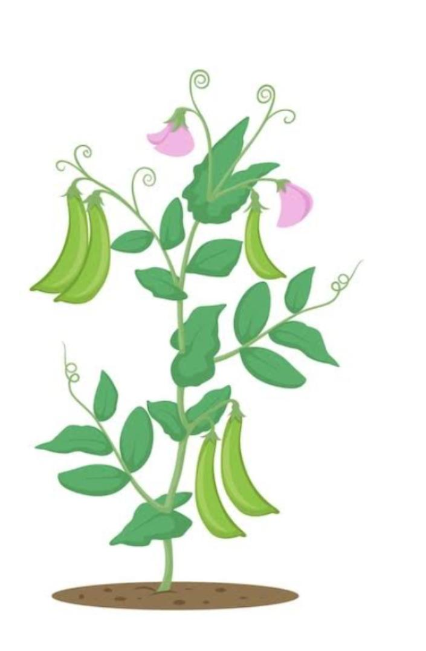
3.In the chapter we have read about sati, whose one leg was affected by polio when she was few months old. She is married now and is worried that her children may also get Polio. She spoke to a doctor and the doctor consoled her by saying “ Dont worry, your children will not be affected by polio”.
- Sati ‘s children will not be affected by polio , why?
Ans – sati children will not be affected by polio as it is a viral disease caused by the Polio virus. It is not inherited and is spread through contact with an infected person. Polio virus does not pass through genes.
ii. How does Polio – virus spread?
- It spreads through contaminated water, food or hands.
- The virus is excreted in the stool and throat secretion of infected person.
iii. What precaution should be taken to prevent this disease?
The disease polio has been preventable since 1960’s by getting either vaccination or oral drops.
4.Who is Gregor John Mendel?
Gregor John Mendel (1822-84) was an Austrian monk who studied genetics. He is also known as Father of Genetics. He conducted many experiments on pea plants to find out that traits pass from one generation to the next.

